Proforma: 7
Alumni Survey  (To be filled by Alumni - after the completion of each academic year) | 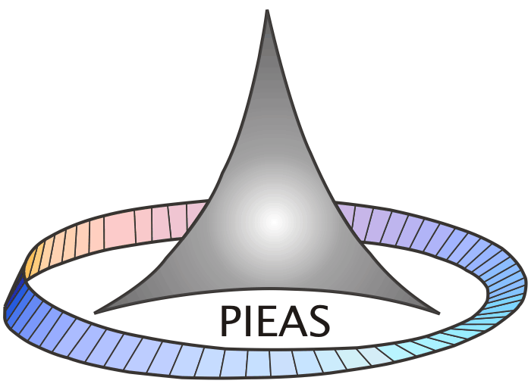

The purpose of this survey is to obtain alumni input on the quality of education they received and the level of preparation they had at University. The purpose of this survey is to assess the quality of the academic program. We seek your help in completing this survey.

5: Excellent | 4: Very good | 3: Good | 2: Fair | 1: Poor

Item | Marks
1. Knowledge
- Math, Science, Humanities and professional discipline, (if applicable)
- Problem formulation and solving skills
- Collecting and analyzing appropriate data
- Ability to link theory to practice.
- Ability to design a system component or process
- IT knowledge
II Communications Skills
- Oral communication
- Report writing
- Presentation skills
III Interpersonal Skills
- Ability to work in teams.
- Ability to work in arduous /Challenging situation
- Independent thinking
- Appreciation of ethical Values
IV Management /leadership Skills
- Resource and Time management skills
- Judgment
- Discipline

V General Comments
Please make any additional comments or suggestions, which you think would help strengthen our programs. (New courses that you would recommend and courses that you did not gain much from)
________________________________________________________________________________________________________________________________________________

VI. Career Opportunities : __________________________________________________
VII. Department Status
- Infrastructure
- Faculty
- Repute at National level
- Repute at international level
VIII Alumni Information
Name (Optional)__________________Name of Organization___________________________
Position in organization____________Year of graduation________________________ ______

