Online Application Form
For
USAID-funded Merit and Needs Based Scholarship Program

Main steps:

- Type http://eportal.hec.gov.pk in your browser like Firefox, Google Chrome, internet explorer

- Create an account (Register on HEC Portal)
  - Verify SMS Code
  - Verify Email Code

- Login with the CNIC and Password

- Create Profile
  - Personal Information
  - Academic information
  - Other details

- Apply for Scholarship(USAID-MNBSP)

- Type http://eportal.hec.gov.pk and and Click “Register” on below screen

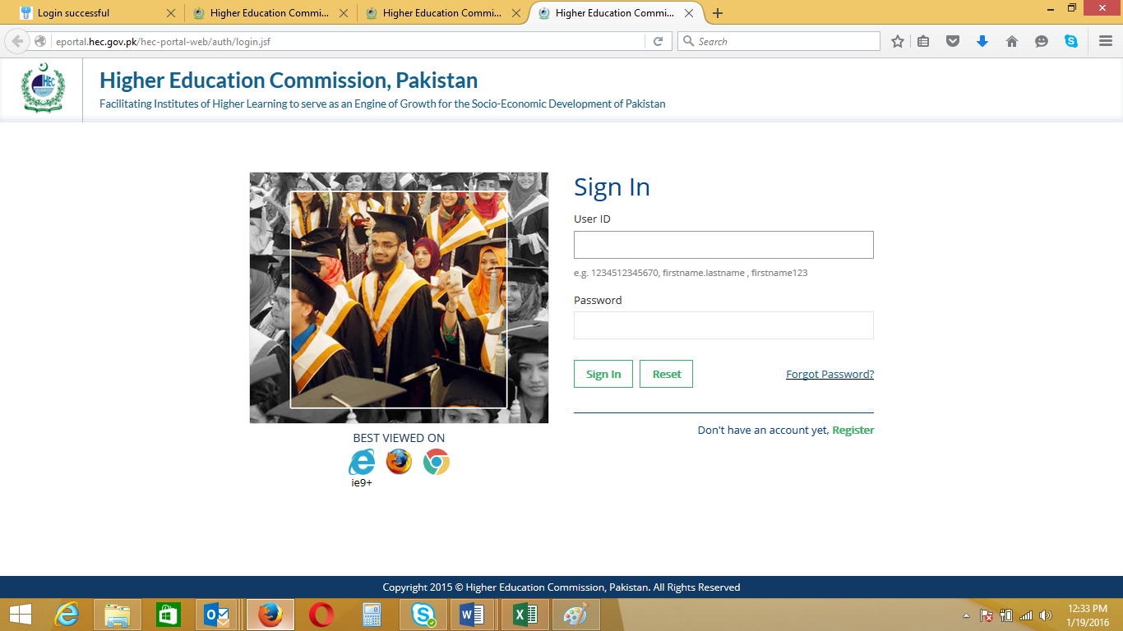

- Create an Account
  - Choose Your Nationality, Enter CNIC without “Dashes”, Set & Confirm Password
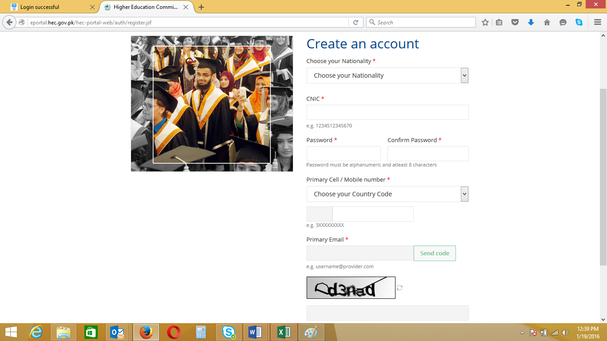

- Choose Country Code and type your cell no without zero ”0”
- Click “Send Code”

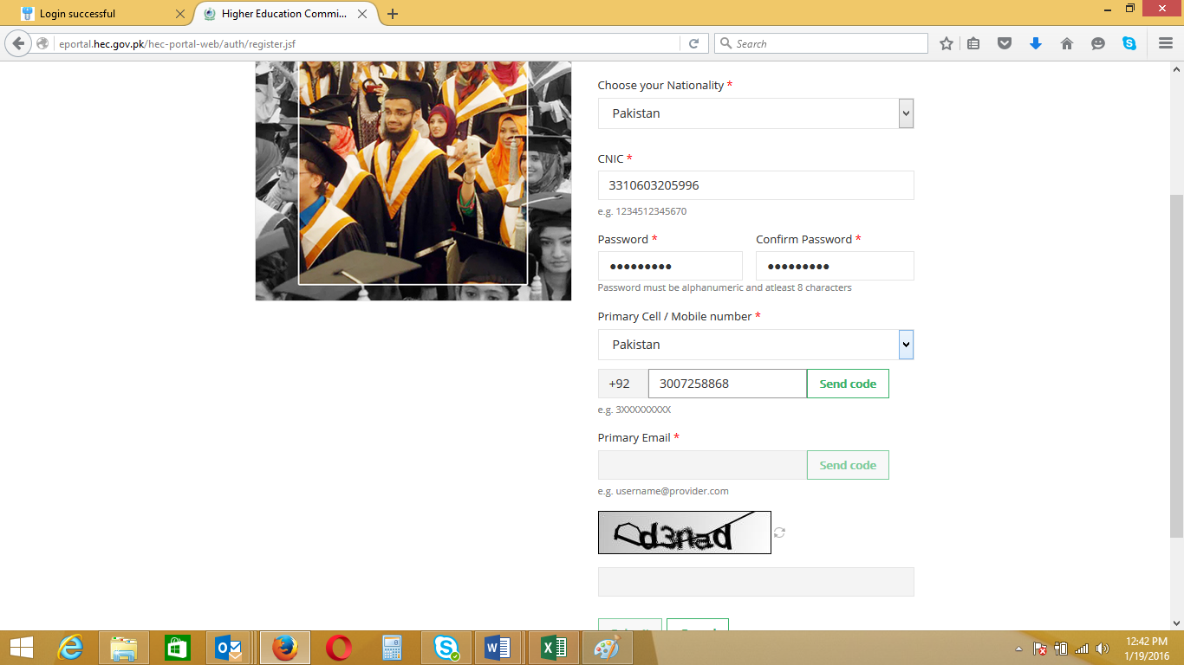

- You will receive message on screen ”Code Sent to Cell Number Successfully”

- If code not received on Cell Number Click “Resend Code”

- Enter Code and click “Verify Number”

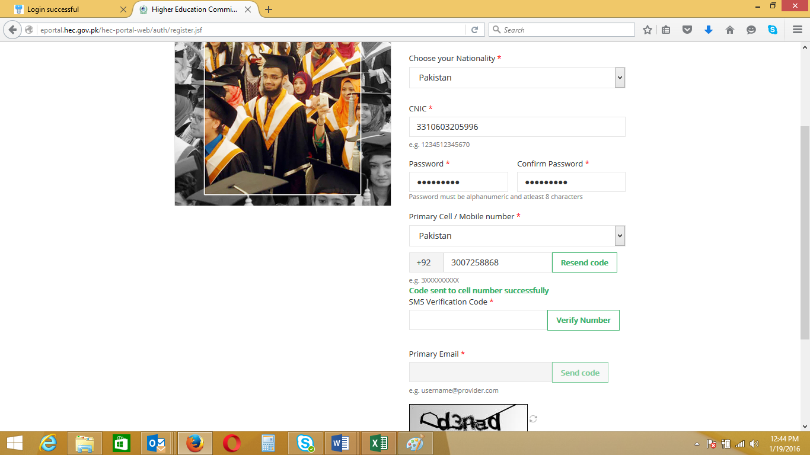

- You will receive “SMS Code Verified Successfully”
- Enter “Primary Email” and click “Send Code”
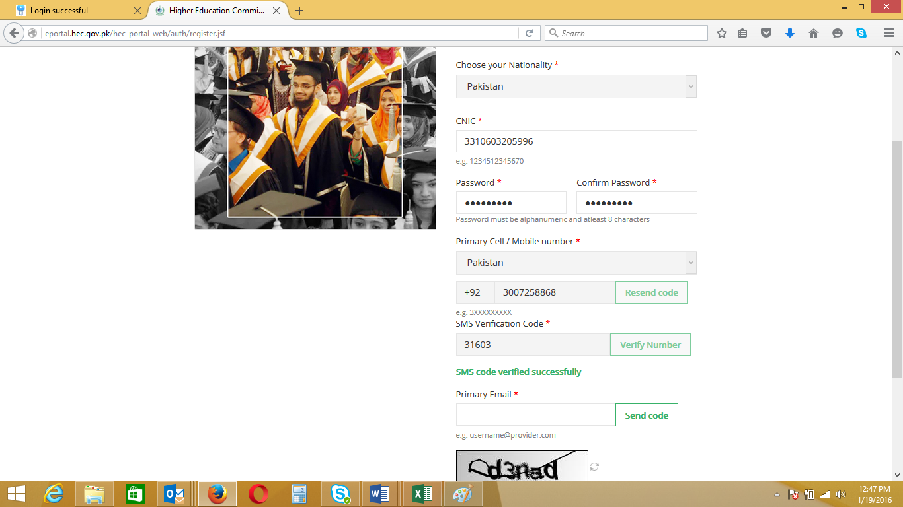

- You will receive message “Code sent to email successfully”
- Open email and type Number and click “Verify Email”
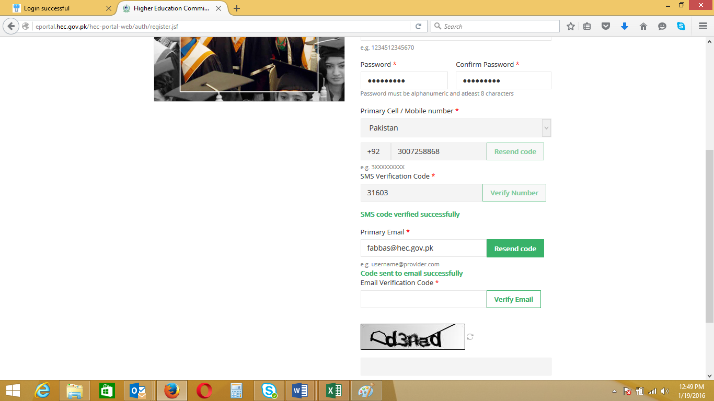

- Email received

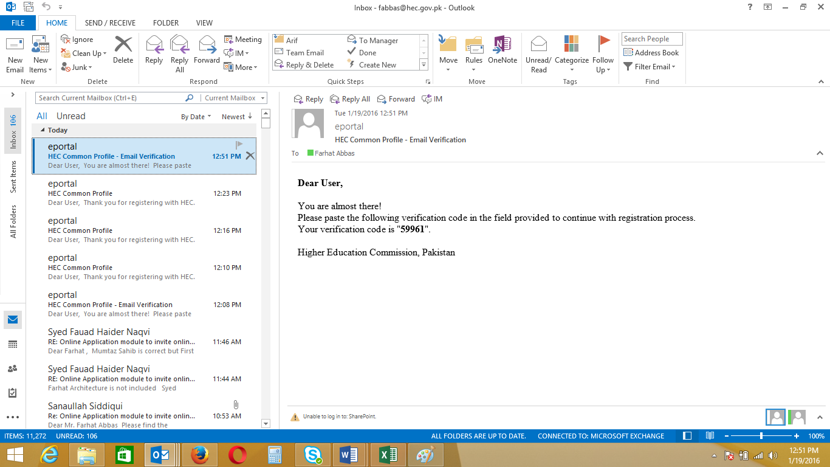

- You will receive a message “Email Code verified successfully”
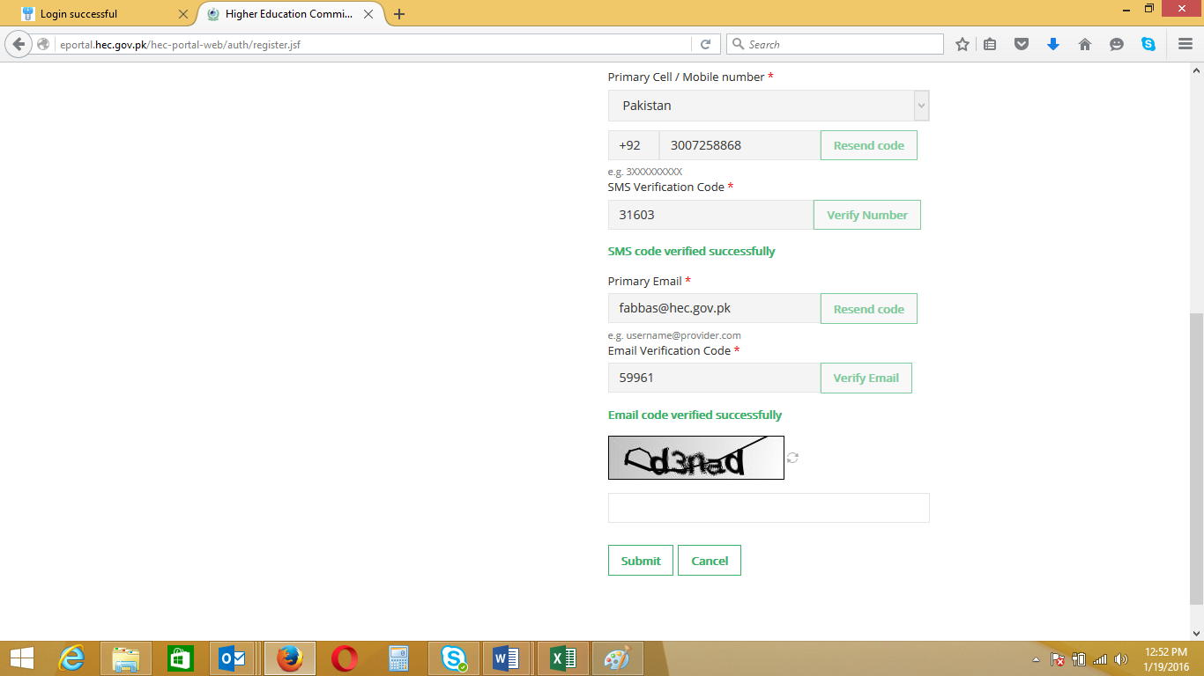

- Enter “Captcha Code”
Captcha Code

- Enter Captcha Code as in below screen and click “Submit”

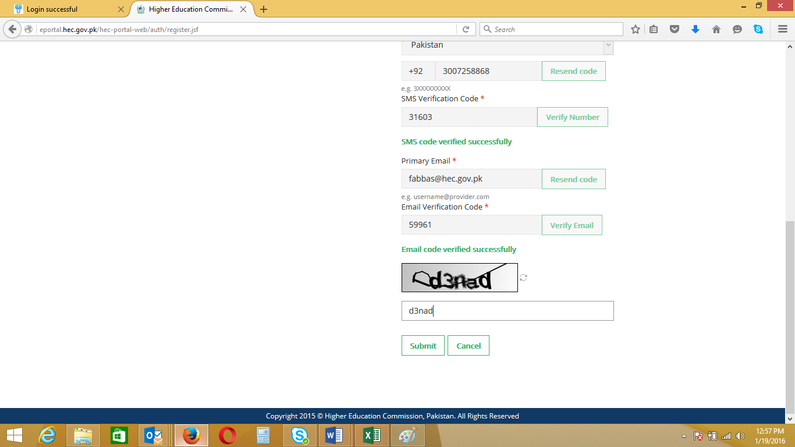

- You will receive a message as in below screen

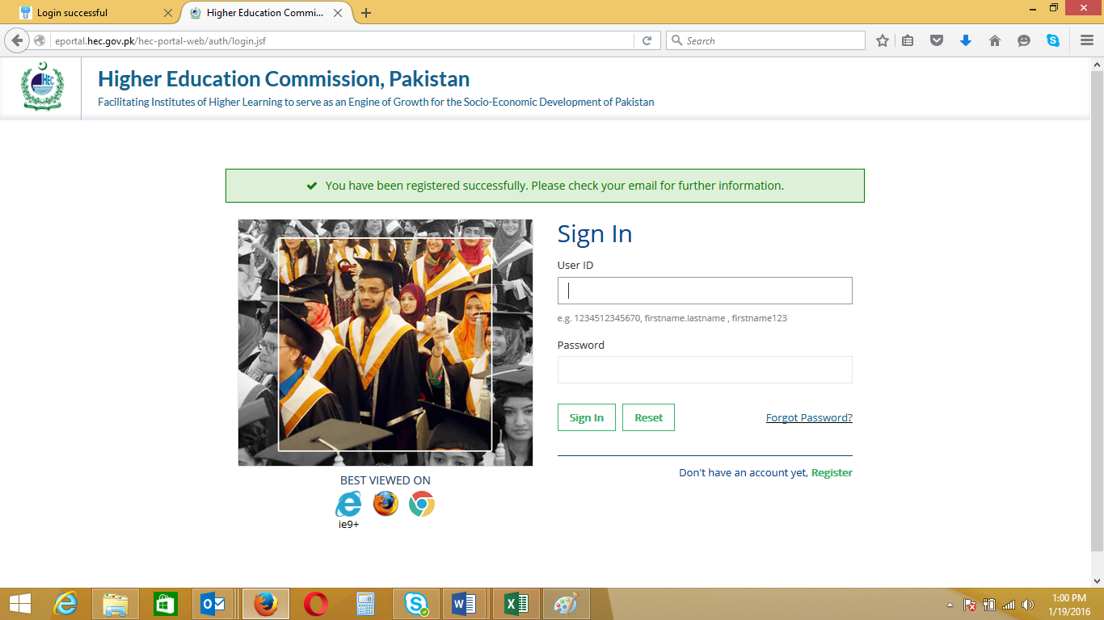
- Email Received

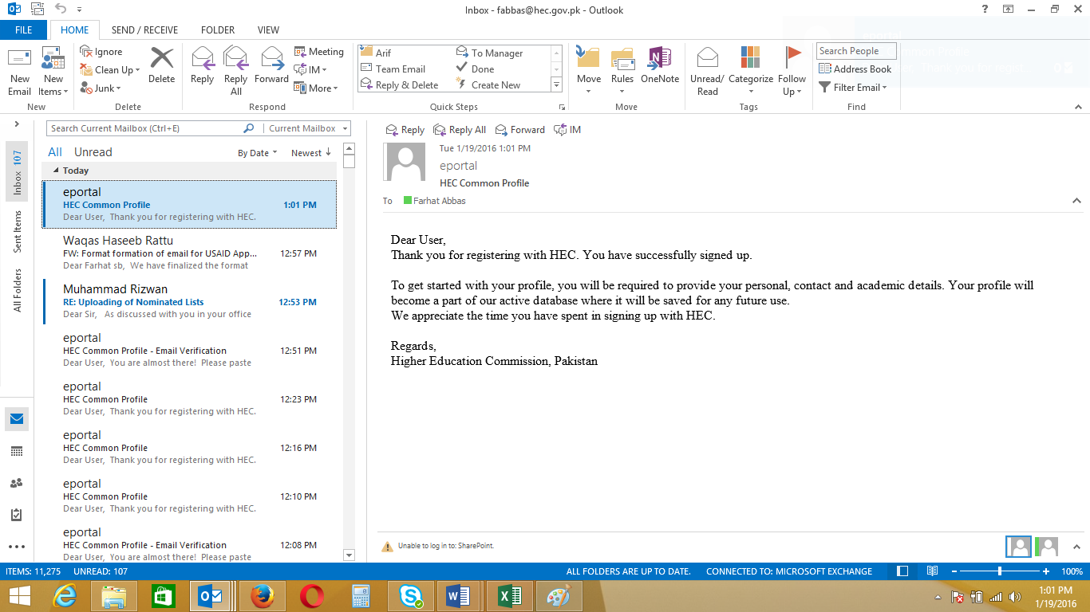

- Please Login with CNIC and Password as below and click “Sign In”

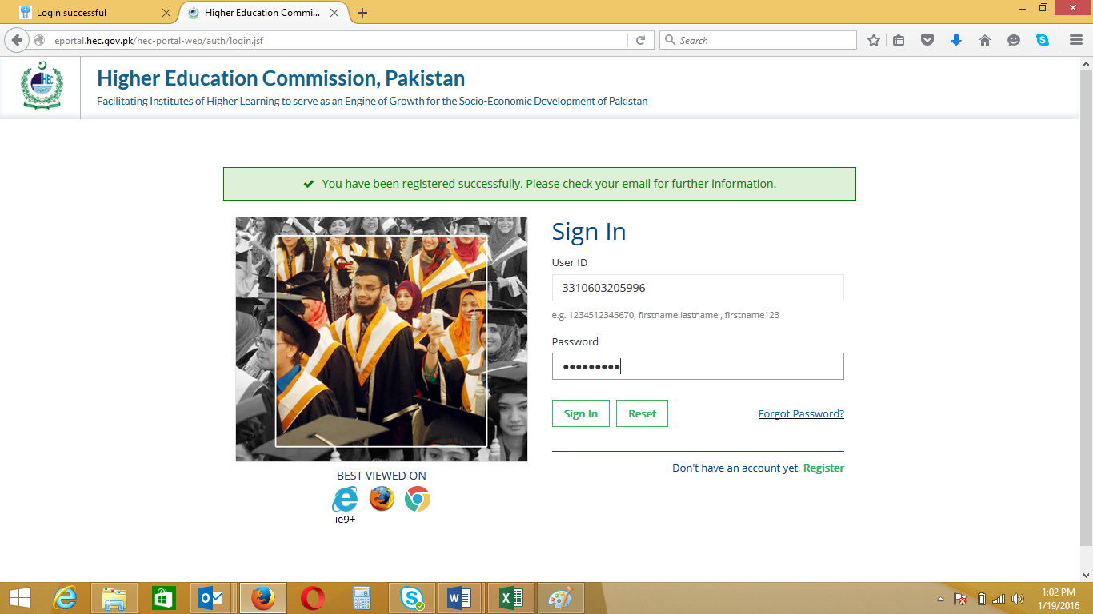

- If you forget password, please click “Forget Password” on above screen

- This is “My profile” screen. It consists of 11 Tabs

- Click each Tab on eby one and fill the relevant fields

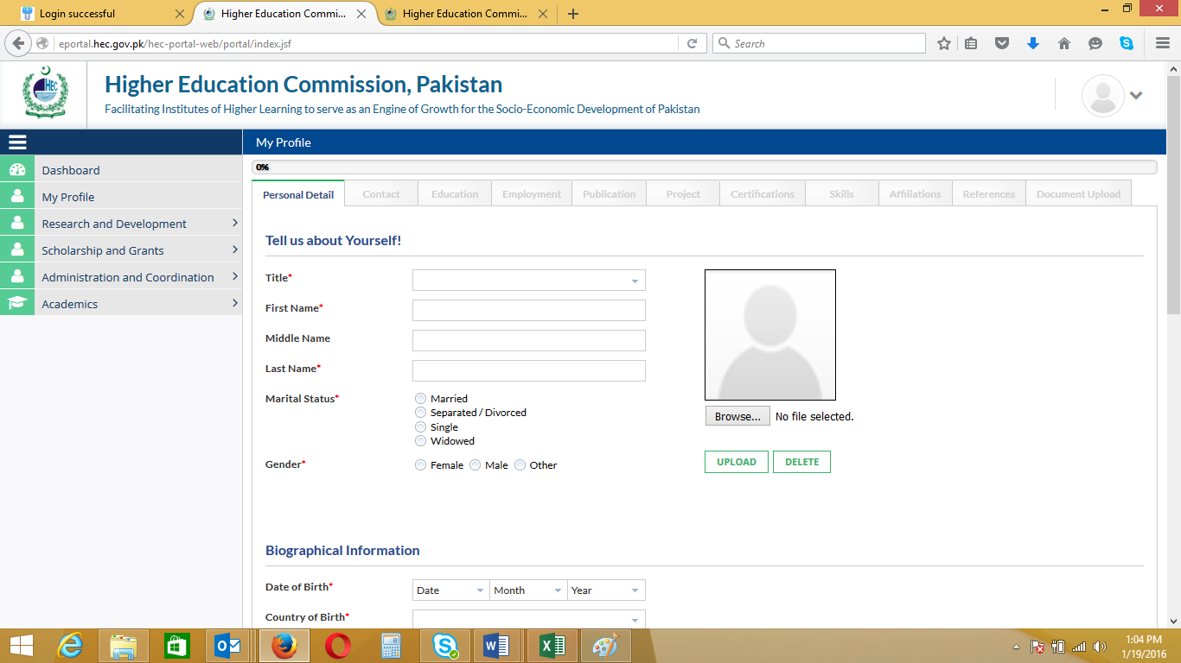

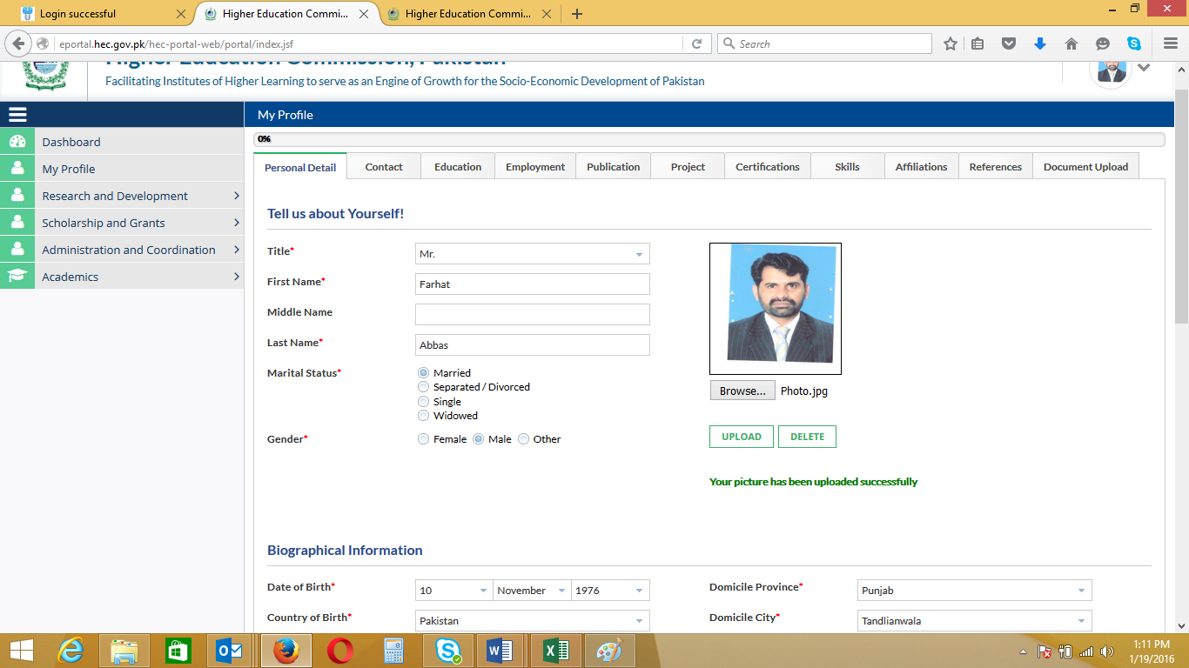

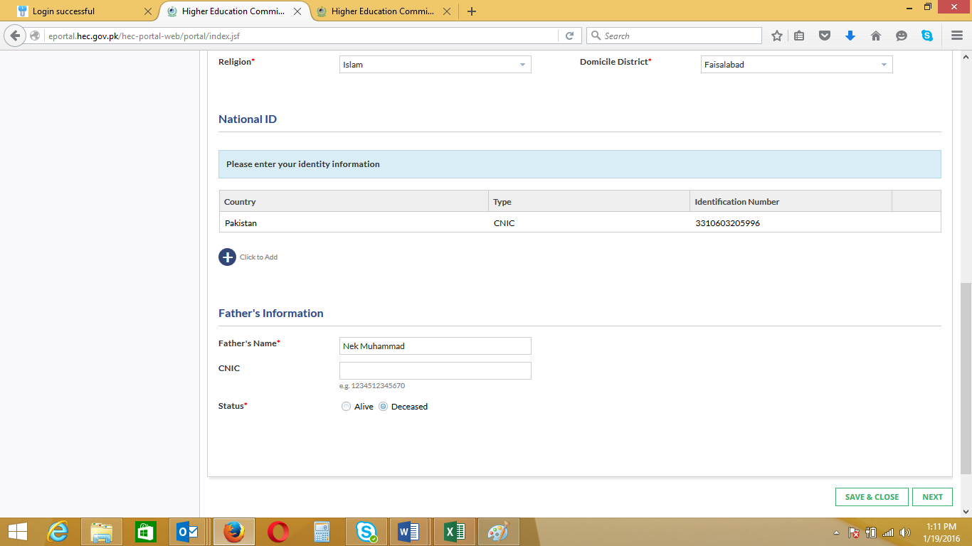

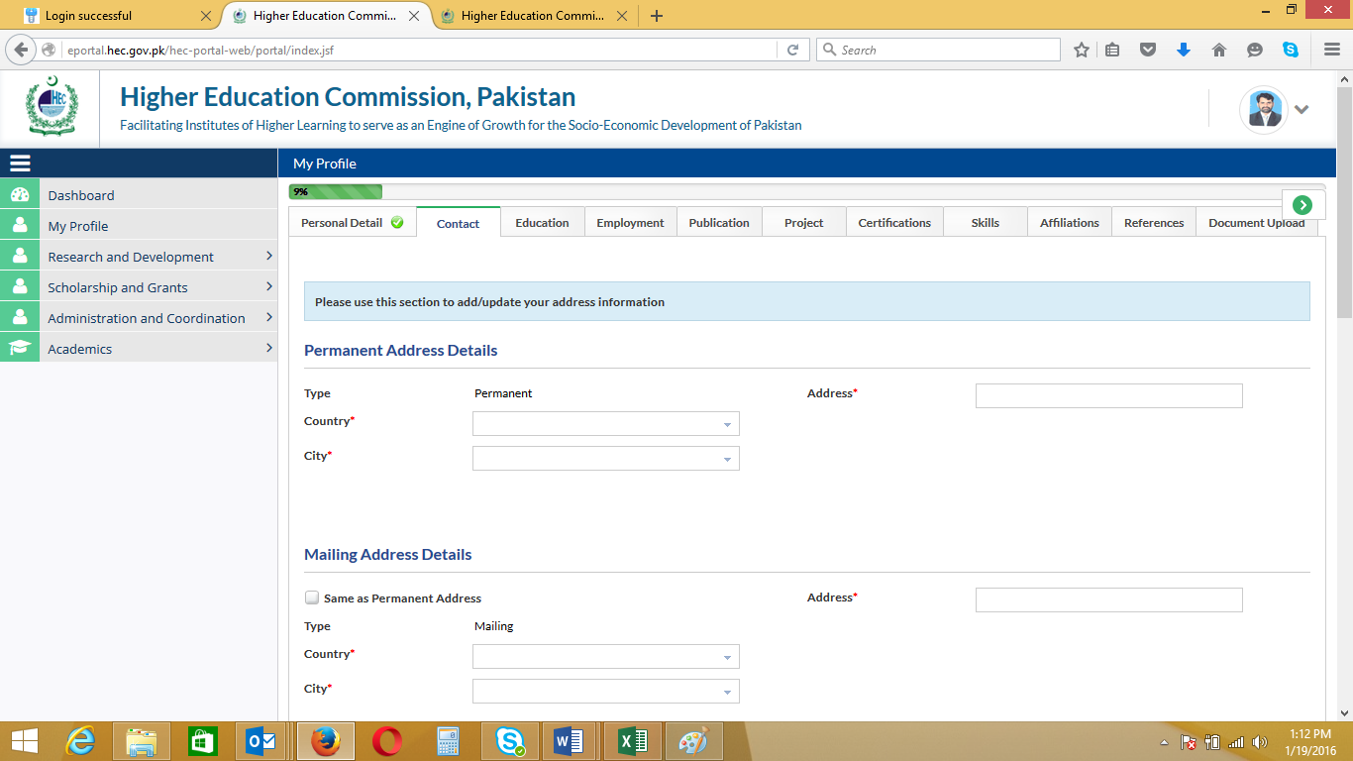

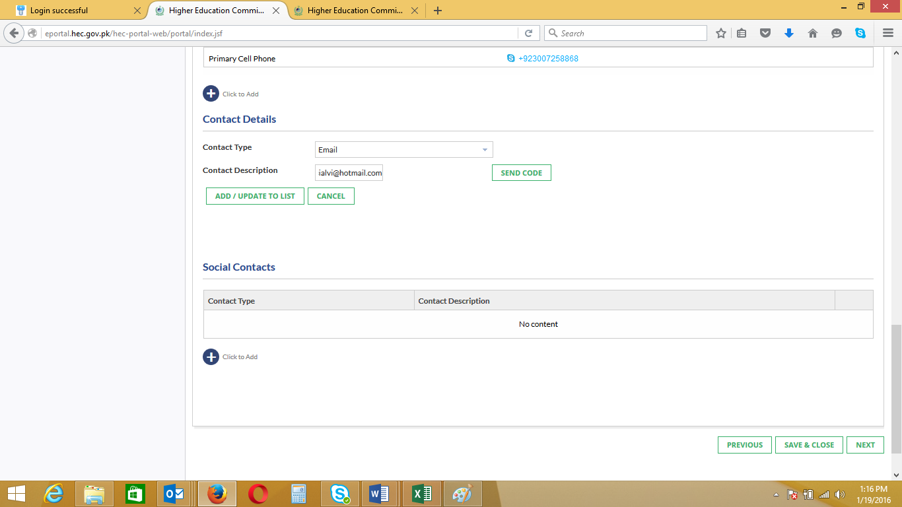
- You can add additional Contact also by clicking “+” sign below the “Contact”
- It will also require code verification, Click “Send Code”
- Enter code and click “Add
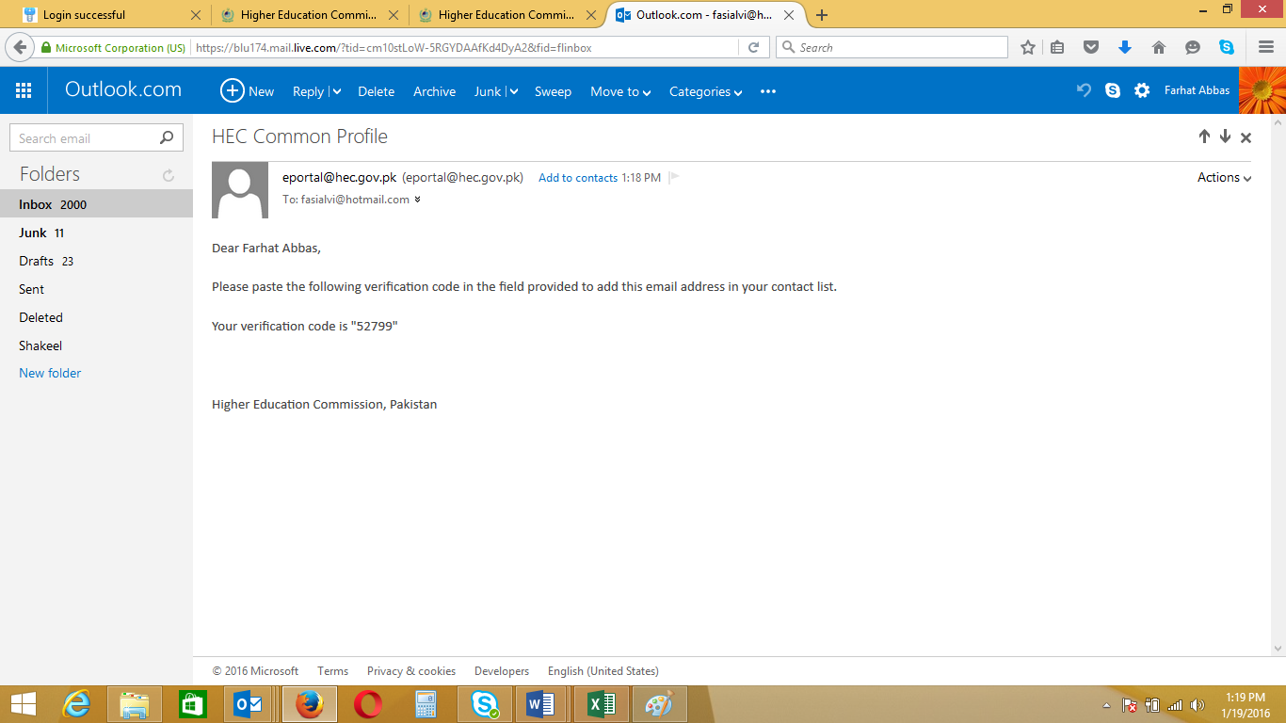
- New Email Added
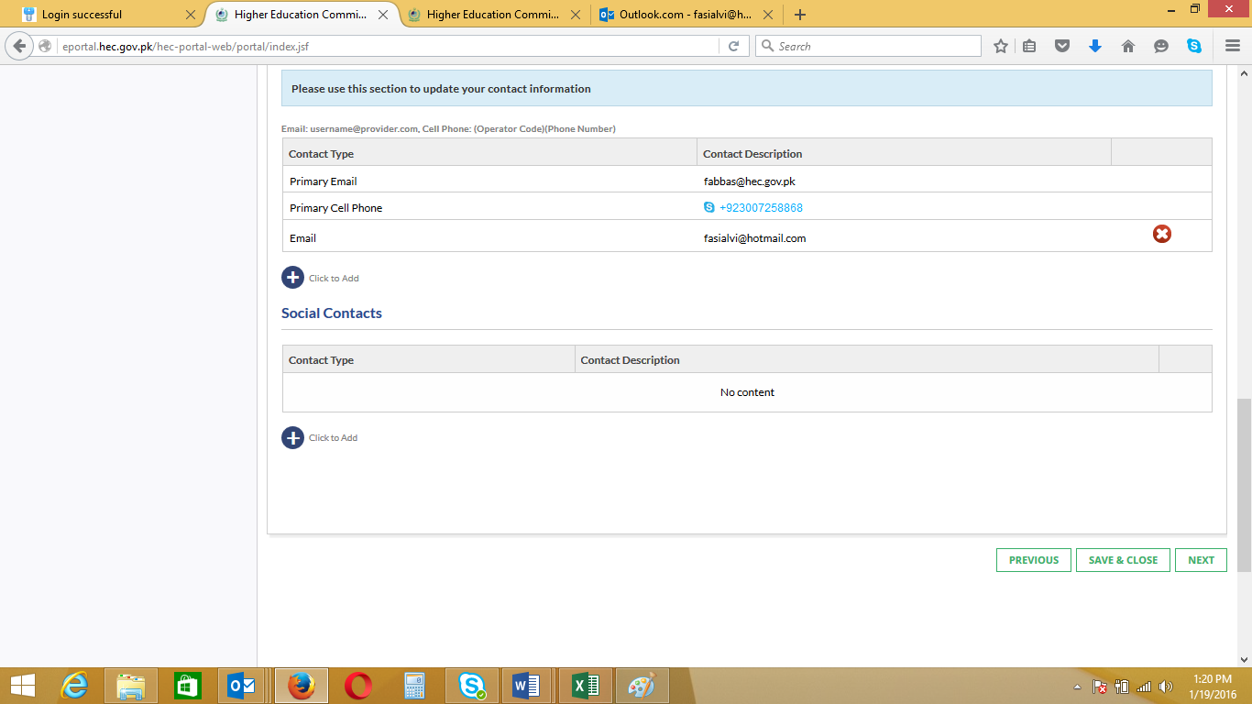

- “Education” Tab contains Qualification Level
- Click “+” sign and insert first level
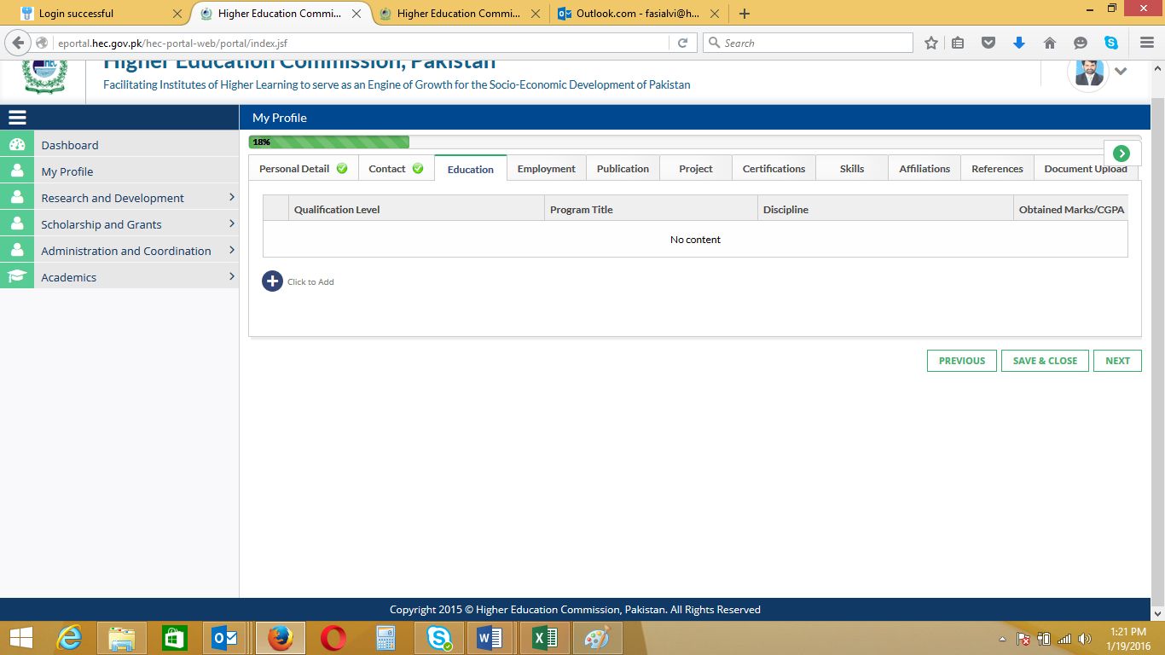

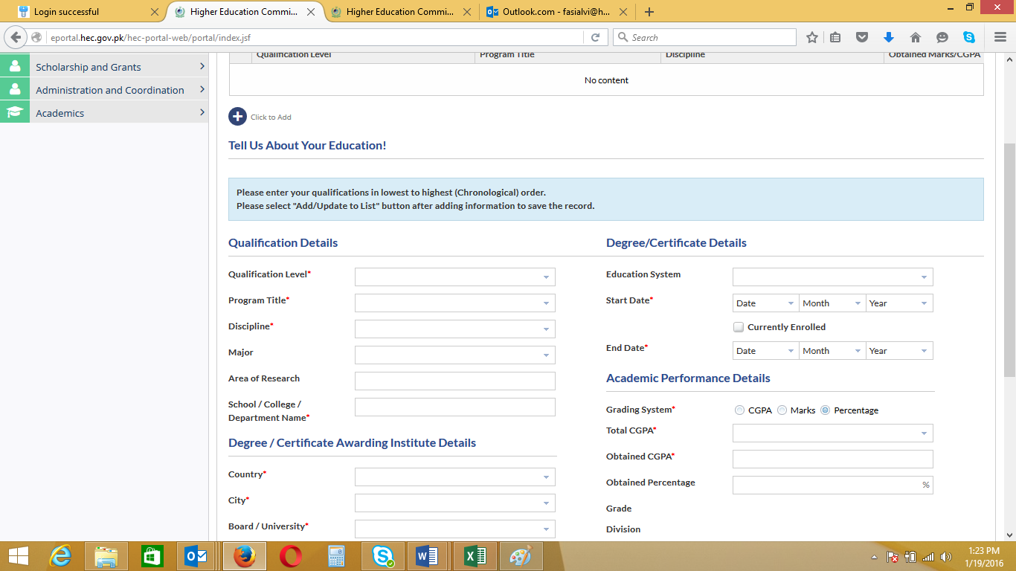

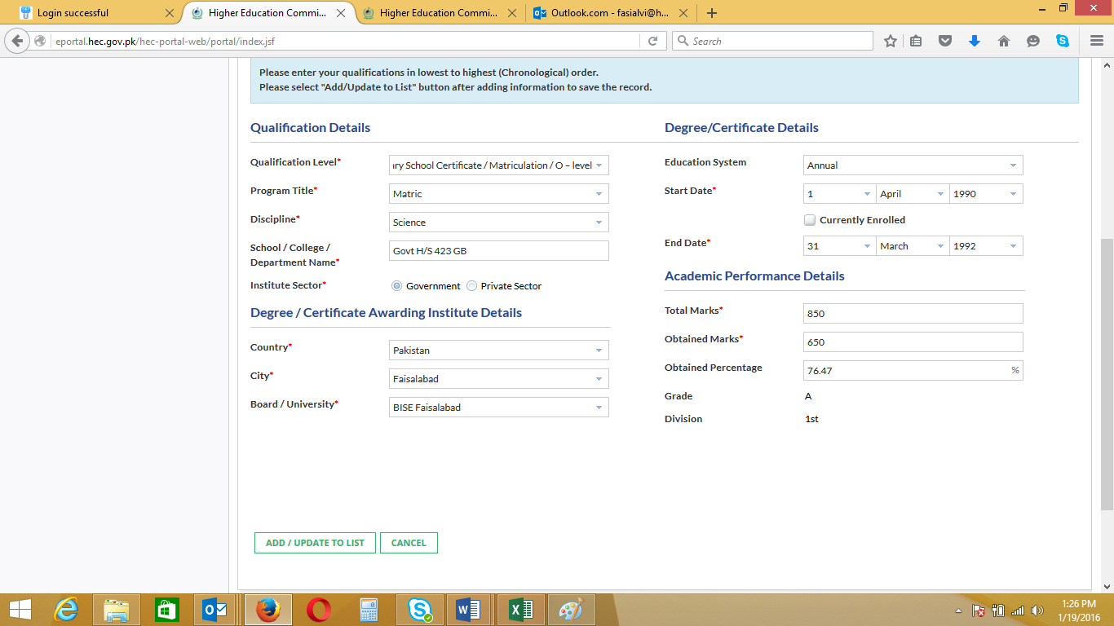

- Click “ Add/Update to List”

- If you want to Edit the information under “Education”, Click the Circular Button on the left side of the updated Qualification Level as in below screen

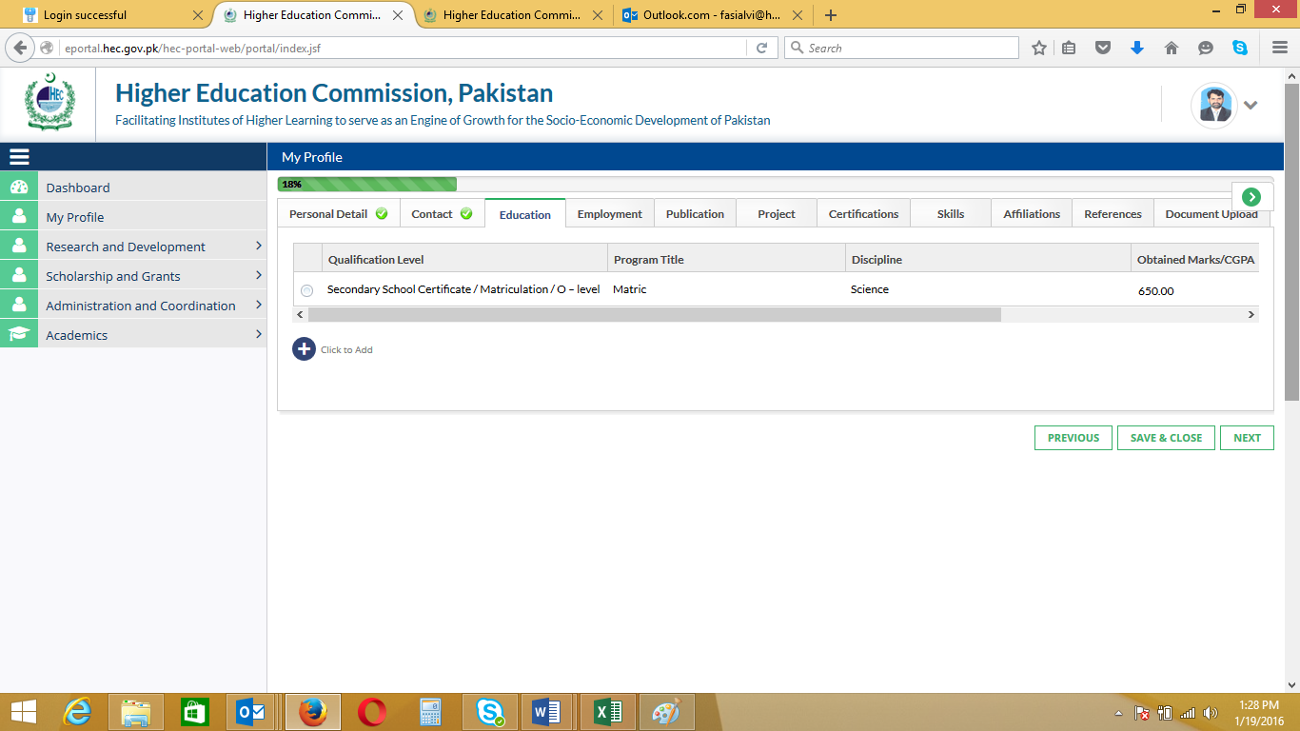

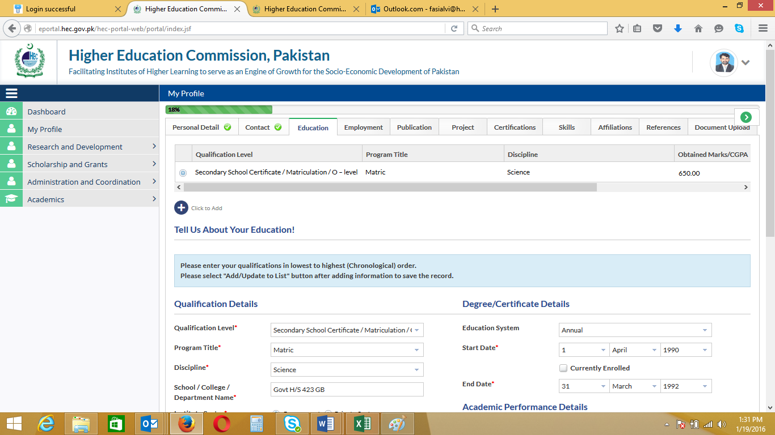

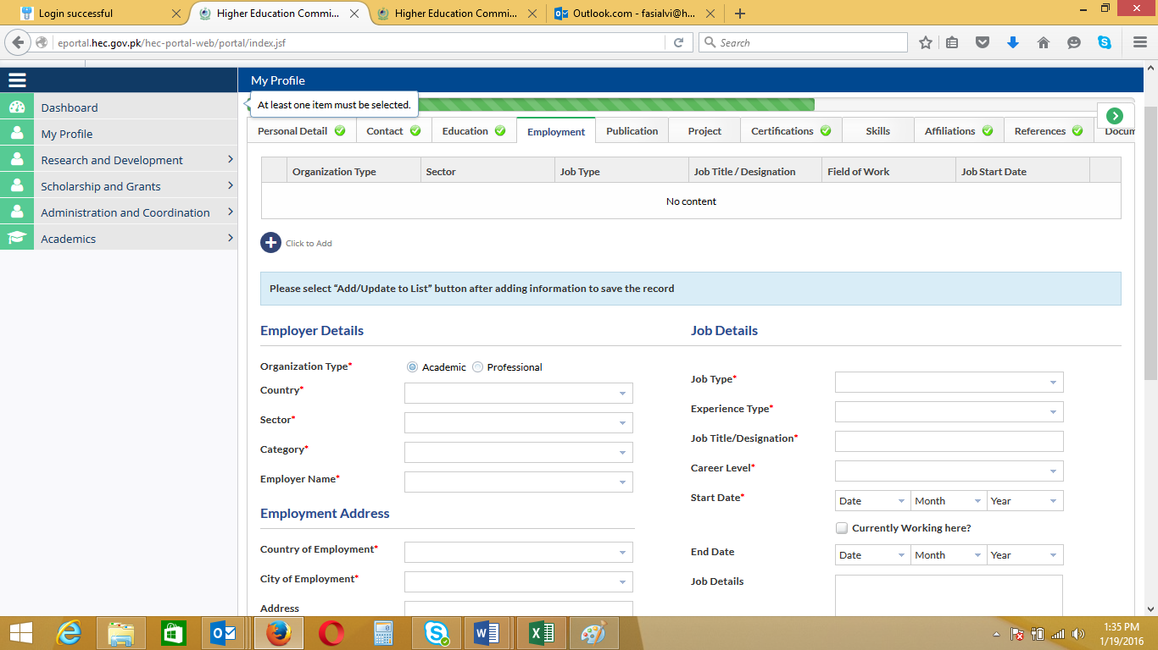

- Add information under all Tabs

- How to Apply for USAID Scholarship

  - When you complete Profile and Click “Save & close”, you will see the below screen
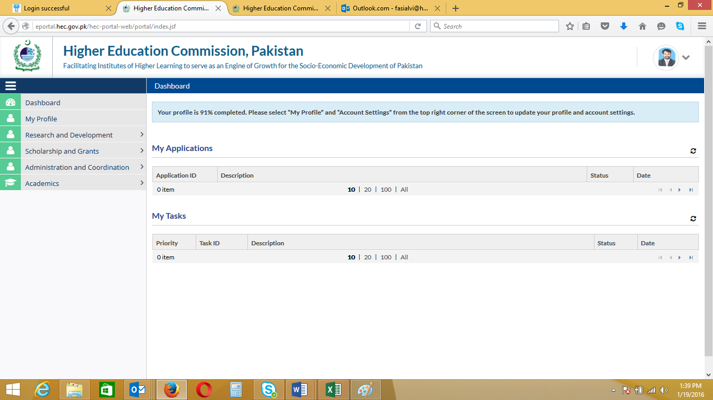

- Click “Scholarship and Grants”
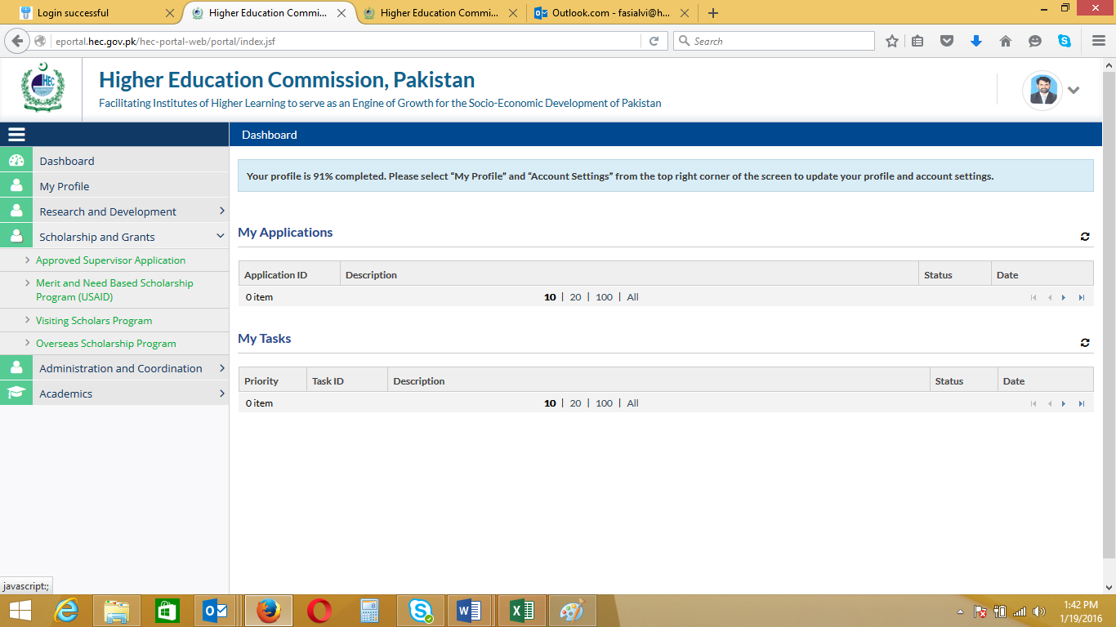
- Click Merit and Need Based Scholarship Program
- You will see the below screen
- Click Application Form

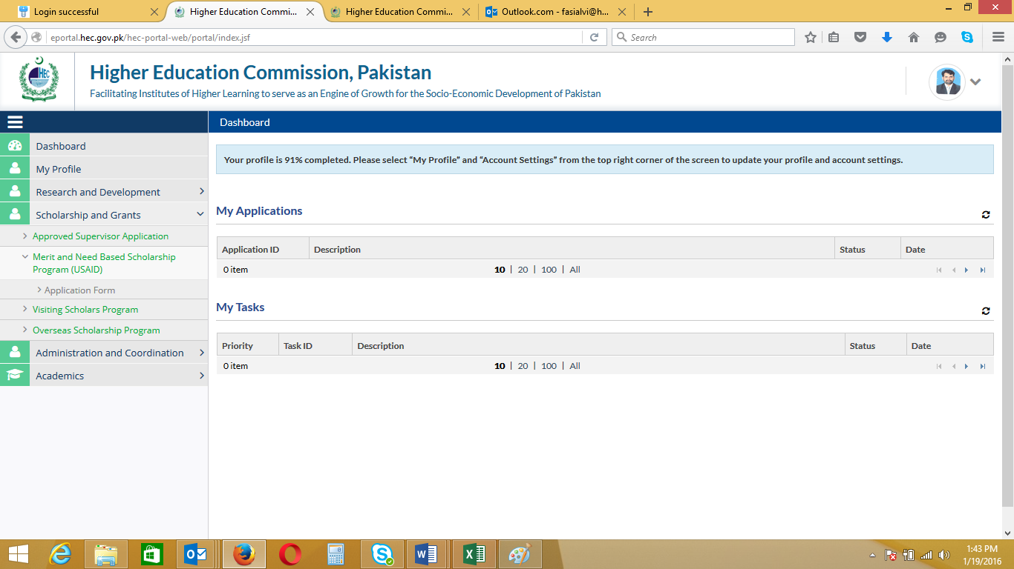

- Below screen will be displayed and click “Yes/No” for AJK/Pakistani
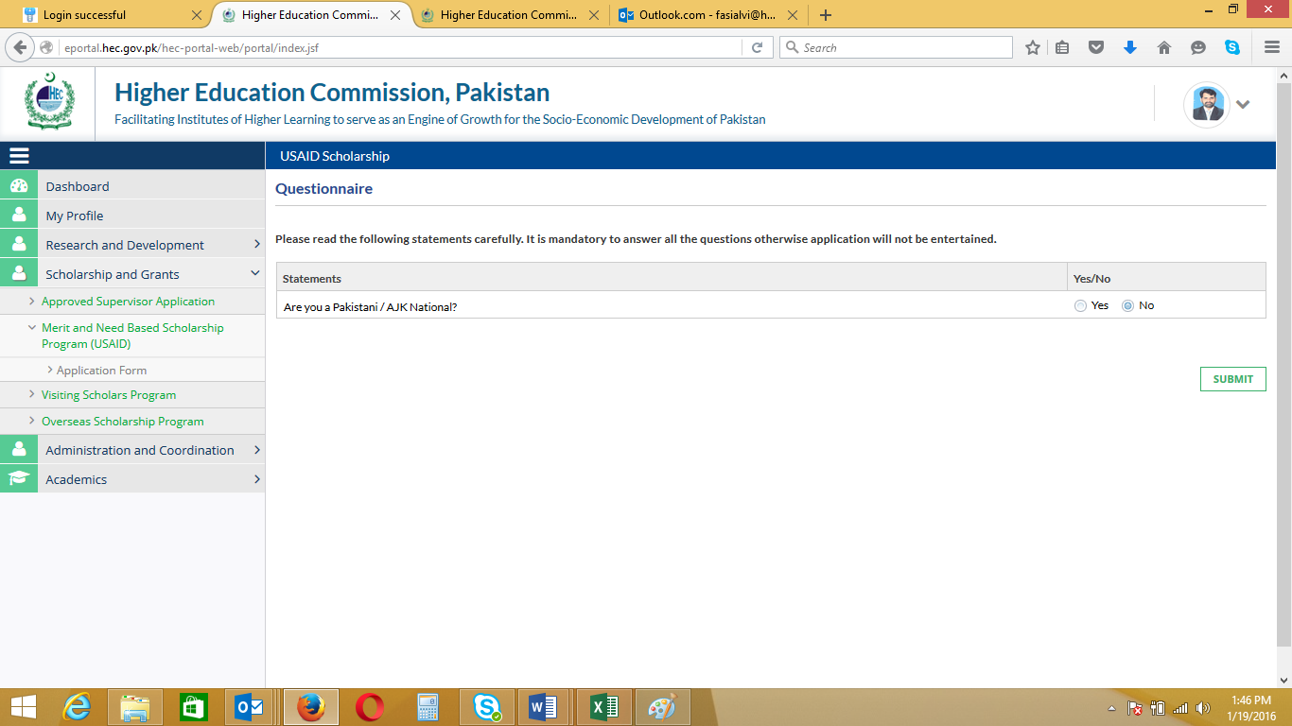

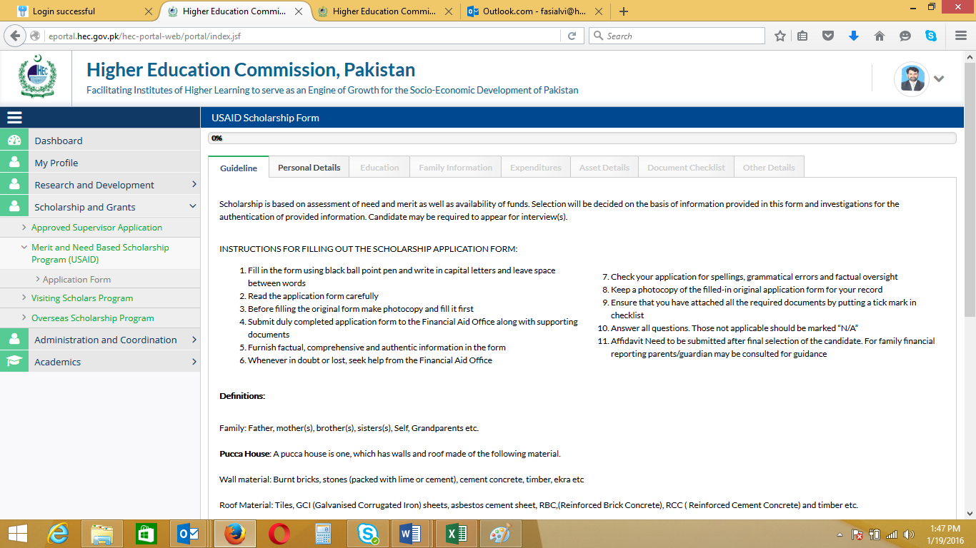

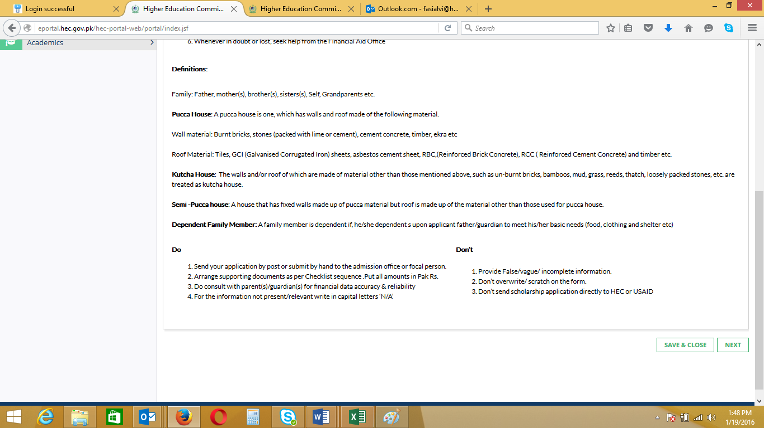

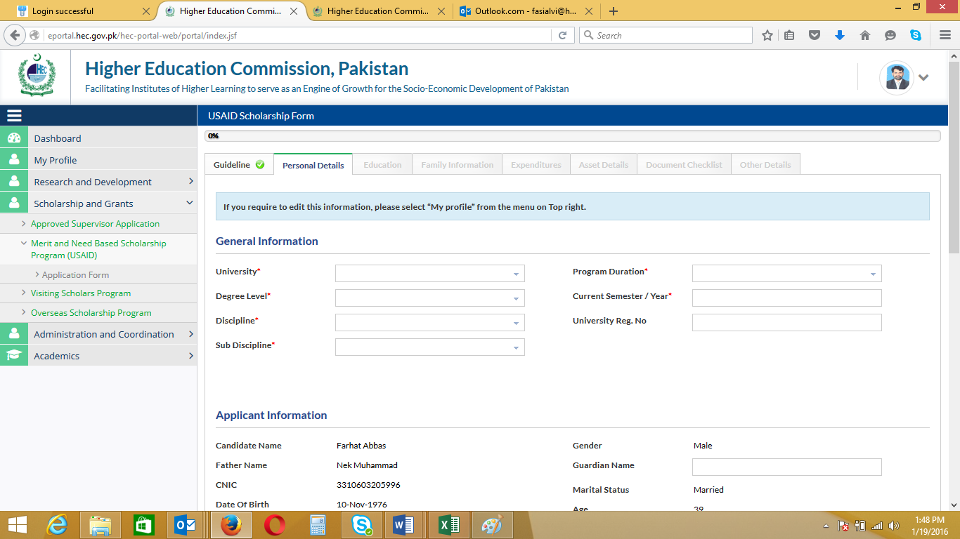
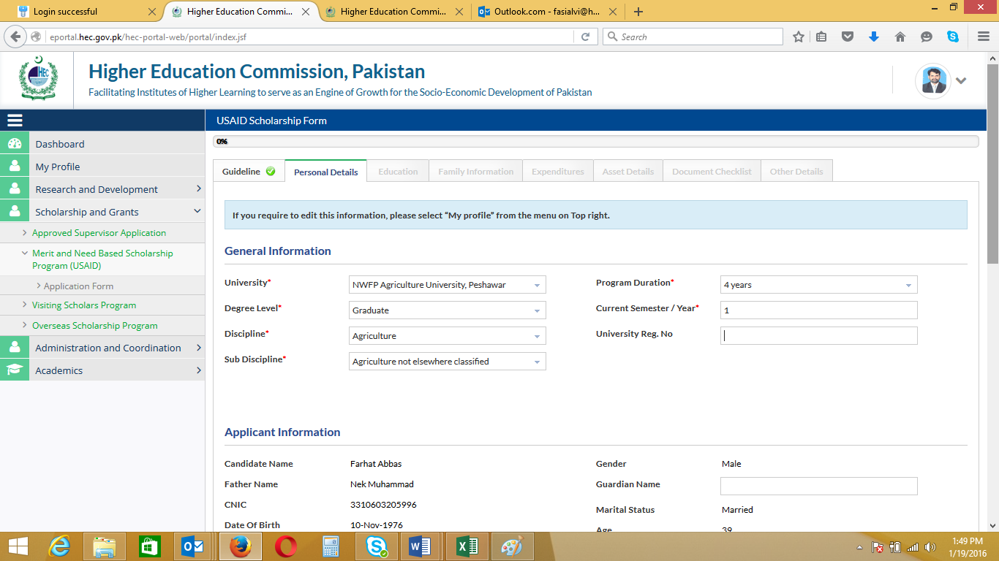
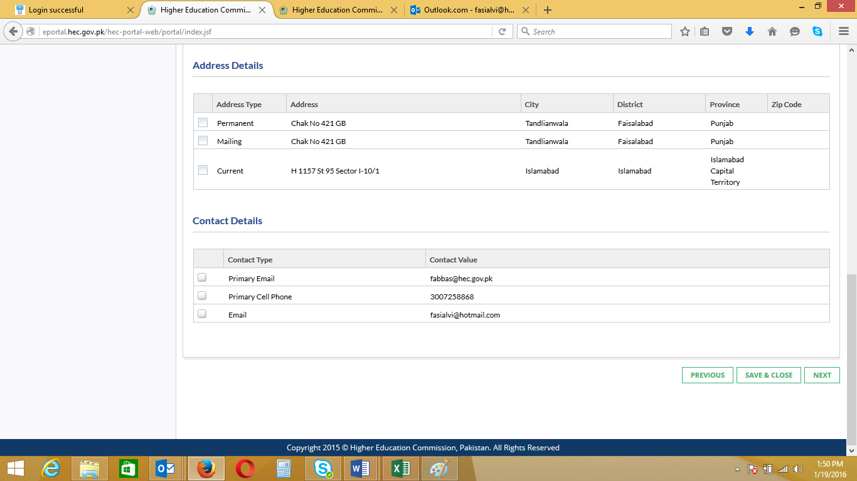
- The fields have been already updated in Profile and also required in Application Form will be filled automatically while Applying for Scholarship
- The fields not updated are required to be updated under each Tab
- After entering data under all tabs, click “Submit”

- The below screen shows the submitted form under Dashboard
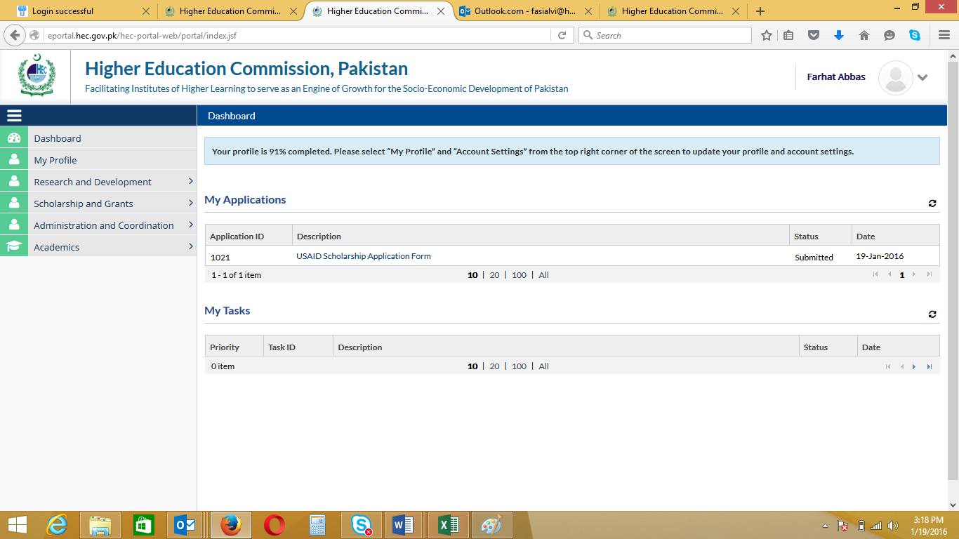

Please Note that :

- The submitted Form cannot be edited. Please check saved information carefully before click “Submit”.
- You can upload the required documents also
- Print Form by clicking “Print Application” and attach your copies of required documents
- Submit to the financial Aid office

